Affiliate Toolkit: Local Business Outreach for MARWeek 2026
Purpose: Use this toolkit to invite local businesses, restaurants, retailers, wellness providers, and franchises to recognize medical assistants during Medical Assistants Recognition Week (MARWeek) 2026 by offering discounts, deals, appreciation events, or storefront recognition.
Quick MARWeek Overview
Medical Assistants Recognition Week (MARWeek) is a national celebration honoring the vital contributions medical assistants make to patient care, health care teams, and the communities they serve. MARWeek 2026 will be observed October 19–23, 2026, with the theme “Educated. Equipped. Empowered.”
Affiliates requested a ready-to-use outreach resource to help encourage local business and franchise participation. This document is designed so state societies and chapters can customize the sample letter, share participation ideas, and point businesses to official AAMA MARWeek materials.
At-a-Glance: What to Ask Local Businesses to Do
Participation Option | How It Could Work
Offer a discount or deal | Examples: 10% off, buy-one-get-one offer, free coffee, dessert, car wash, wellness service, or retail promotion.
Create a medical assistant appreciation moment | Examples: prize drawing, gift basket, sponsored lunch, “thank you” table, or staff shout-out.
Display the MARWeek supporter sign | Participating franchises and businesses are encouraged to print and hang the “Proud Supporter of MARWeek” sign in their storefront.
Use the official MARWeek logo | Businesses should use the official MARWeek logo in approved local promotions, social media posts, signage, or digital materials.
Share the offer details early | Ask businesses to confirm the offer, active dates, location restrictions, and proof-of-eligibility requirements before affiliates promote it.

Sample Letter Template for Affiliates
Tip: Customize the bracketed fields before sending. Affiliates may use this as an email, printed letter, or talking-point script for in-person outreach.

[Affiliate/Chapter Logo]

[Date]

[Business Name]
[Contact Name]
[Business Address]

Dear [Contact Name],

On behalf of [State Society/Chapter Name] and the medical assistants who serve patients throughout our community, we invite [Business Name] to join us in celebrating Medical Assistants Recognition Week (MARWeek) 2026, observed October 19–23, 2026.

MARWeek is a national observance dedicated to recognizing the vital contributions medical assistants make every day. Medical assistants support both clinical and administrative functions in physician practices, clinics, health systems, and other care settings. They help keep patient care moving while contributing to safe, efficient, and compassionate health care.

The 2026 MARWeek theme, “Educated. Equipped. Empowered.”, celebrates the knowledge, skills, professionalism, and dedication medical assistants bring to their work and to the patients and communities they serve.

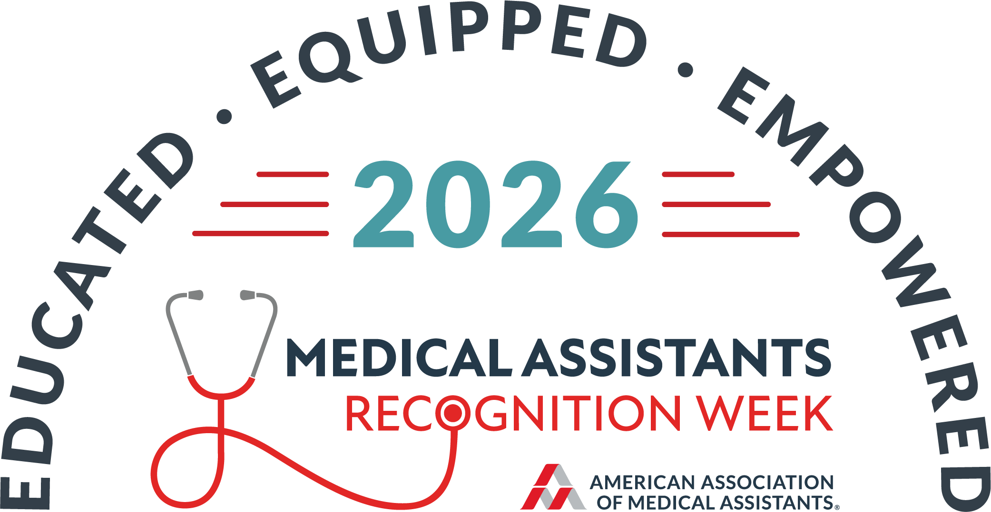

We would be grateful for your support in recognizing local medical assistants during MARWeek. Participation can be simple and meaningful. Your business might offer a special discount, limited-time deal, giveaway, appreciation event, storefront sign, social media shout-out, or another recognition opportunity for medical assistants in our area.

Getting involved is a meaningful way to thank a vital health care profession, support local health care workers, increase visibility for your business, and show the community that [Business Name] values the people who help keep health care running.

Participating businesses are encouraged to use the official MARWeek logo in promotional materials and to display the included “Proud Supporter of MARWeek” sign in storefronts, offices, or customer-facing spaces. If you need help with logo usage, design questions, marketing ideas, or general MARWeek information, please contact Gina Mokijewski, AAMA Marketing Director, at gmokijewski@aama-ntl.org.

If [Business Name] would like to participate, please reply with the promotion or recognition activity you would like to offer, the dates it will be available, and any details medical assistants should know before redeeming the offer.

Thank you for helping us celebrate and recognize medical assistants during MARWeek 2026.

Sincerely,

[Name]
[Title]
[State Society/Chapter]
[Phone]
[Email]

Resources
Official MARWeek logo files | AAMA MARWeek Logos page:  https://www.aama-ntl.org/education-and-events/medical-assistants-recognition-week/marweek-logos
Digital downloads | AAMA MARWeek 2026 Campaign Page:  https://aama-ntl.org/education-and-events/medical-assistants-recognition-week
MARWeek store | https://mar-week.checkoutstores.com/
Design/marketing questions | Direct questions about logo usage, design files, marketing materials, or general MARWeek campaign guidance to AAMA Marketing Director Gina Mokiewski, gmokijewski@aama-ntl.org.

Suggested Social Media Copy for Participating Businesses
“We’re proud to support Medical Assistants Recognition Week 2026! Thank you to the medical assistants who help keep health care moving every day. #MARWeek2026 #MedicalAssistants”

“Educated. Equipped. Empowered. Join us in celebrating medical assistants during MARWeek 2026, October 19–23!”

“Medical assistants play a vital role in patient care and health care teams. We’re honored to recognize them during #MARWeek2026.”

Affiliate Follow-Up Email Template
Subject: Quick follow-up: MARWeek 2026 local recognition opportunity
Hello [Name],

I wanted to follow up on our invitation for [Business Name] to support Medical Assistants Recognition Week 2026. If your team is interested, we would be happy to help promote your discount, deal, appreciation activity, or storefront recognition opportunity to local medical assistants.

Please feel free to send the offer details, active dates, and any location restrictions when convenient. Thank you again for considering this opportunity to recognize medical assistants in our community.

Best,
[Name]
FAQ for Affiliate Chapters

Do businesses need to be health care related?
No. Restaurants, coffee shops, retail stores, wellness providers, gyms, salons, entertainment venues, local franchises, and service businesses can all participate.
Can a franchise participate if only one location is offering the discount?
Yes. Ask the franchise contact to clearly identify participating locations and any restrictions.
Should businesses use the MARWeek logo?
Yes. Participating businesses are encouraged to use the official MARWeek logo in materials that support MARWeek recognition. Questions about design, logo files, or marketing should be directed to gmokijewski@aama-ntl.org.
Should affiliates collect offer details before promoting?
Yes. Confirm the promotion, dates, locations, eligibility requirements, and contact person before including the business in any affiliate communication.
Can affiliates include the storefront poster?
Yes. The “Proud Supporter of MARWeek” poster is included as the final page of this document so participating franchises and businesses can print and hang it in their storefront.
Poster page: The final page is a printable “Proud Supporter of MARWeek” storefront sign. Participating franchises and businesses are encouraged to print and hang this sign in a visible customer-facing area during MARWeek 2026.

