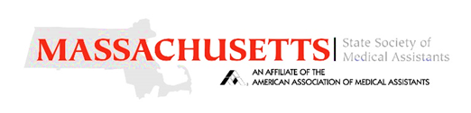 | Location: | 220 Brooks St Worcester, MA 01606  [Please use Higgens St. Entrance]
 | Date: | April 25, 2026
 | Time: | 8:00 am – 2:30 pm
 | Host: | Porter & Chester Institute

MSMA Spring Annual Meeting
- Hosted by the Greater Fall River Chapter (Please bring your current AAMA membership card)

Breakfast & Registration (8:00 am)
MSMA Business Meeting
Officer Elections: MSMA State Officers, Delegates, and Alternates for 2025
- National Conference in Reno, Nevada *Must be present for eligibility*

Topics and Speakers
- 3-4 AAMA CEUs Pending - schedule Subject to Changes without Notice
- Understanding how to Excel for Certified Medical Assistants
  - Dennis R Johnston, Controller
- Reading a Chest X-Ray (CXR)
  - Edward D Struzinski, RN/EMT-P, CEN, CCRN, CFRN
- Compassion Care Hospice
  - Anita Correia Silvia, Account Executive, hospice liaison with Amediysis Hospice

Lunch - Provided (TBD)
- Basket raffle tickets and 50/50 tickets are available
- Four (4) AAMA Memberships will be raffled
If you are not registering online, please return this bottom section with the designated fee to the Treasurer for proper accounting for meals.
Scan to Register Online Form
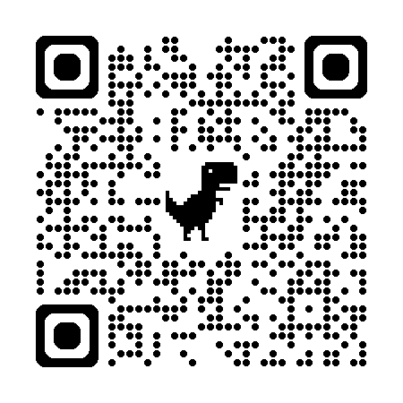
___ MEMBER, $20.00 ___ NON-MEMBER, $30.00 ___ STUDENT, $0.00

- All responses received after 4/17/2026 will be subject to a $10.00 late fee.

Name: ______________________________________ Credentials: _______________ Chapter/School: ______________________

Address: ______________________________________________ Phone: ___________________ Diet Restrictions: ________________

E-Mail: ___________________________________________ Check #: __________ Amount Enclosed: __________ Member ID#___________

First Timer Student – School Name ____________________________________________________ Non-Member

CHECKS PAYABLE TO MSMA
MAIL PAYMENT TO: Tiffany Heath, CMA (AAMA) MSMA - 66 Dimmick Street Springfield, MA 01109

For Questions or concerns, please contact: MSMA State President - Dawn Jordan-Leblanc, CMA (AAMA) via (508) 754-3485 and/or DGJCMA@aol.com

WE HOPE YOU CAN JOIN US!
http://www.medicalassistant.org/

